Reading dental x-rays with computer supervision through neural networks

Erwin Plaza Copajira
CCT College
Dublin, Ireland
20024033@cct.ie

Abstract—Since dental radiographs have been used, they have facilitated the prognosis of patients' problems and the work that has been done on specific teeth. Although this has helped to get a better picture of the procedures to be performed for proper care, some problems cannot be detected without the full concentration of the practitioner in charge. And whether due to the inexperience of the practitioner or the pressure of handling several cases a day, this can take too much time and be inefficient in providing optimal service. Using artificial neural networks (ANNs), convolutional neural networks (CNNs) will reduce the time and increase the accuracy of displaying these results. This will improve patient care and treatment, and can be used to teach future professionals to detect dental problems such as cavities, obstructions and possible procedures. Neuronal networks applied in this area are a solution that must be present in order to make decisions on the best treatment for each individual.

Keywords—"Convolutional Neural Networks", "Dental X-rays", "Caries Detection", "Supervised Learning", "Computer Vision" ;” hadoop”;” Apache spark”.

Introduction
Artificial intelligence (AI) has one area, machine learning, which gives systems the ability to learn and improve automatically without being explicitly programmed [1,2] based on historical data. The systems obtain results through a model that receives text or images as input. There are different types of neural networks and we can classify them according to their topology or structure or learning algorithm. By directionality they can be monolayer and multilayer. The topology depends on the number and type of layers, which can be input or output and visible or invisible.

By how it learns the patterns we distinguish supervised, where the results are labelled, unsupervised, where the results are not known, and finally we have the intermediate one, which is reinforcement learning [3].
The most common of these is supervised learning.
In the case of images we must get a dataset of images and label each one in this case we have a dataset that was previously classified by 2 professionals in the field. Then we move on to training.
One type of deep and feedback network is the convolutional neural network (CNN) which is the most appropriate for imagery.
In the training process, data is fed into the network, which is passed between layers and then an output is calculated based on the current set of model weights. For the best score of all classes or categories an objective function must be calculated which measures the error. Then the algorithm will change its internal parameters to get the highest score of all categories. At the end, the performance of the system must be measured on a set of different images called test data. The validation test will serve to evaluate the capability of the model to get good responses on new images that it has never seen in its training.[5] The validation test is a test of the model's ability to get good responses on new images that it has never seen in its training.
CNNs process multiple matrices as images and have a multi-layered architecture.
Deep learning has been shown to be an area that is very useful for the study of radiographs [6,7]. It can help to identify and detect images such as tooth, caries, implants and obstructions between teeth.
Detecting early caries lesions and providing treatments that help to avoid more invasive therapies [8] are the most common activities in dental practice.
The International Caries Detection and Assessment System (ICDAS) was founded by an international team of caries researchers to improve a standardised caries detection and assessment system [9], in which caries-related terms were also agreed upon [10].
All over the world the most common dental disease is dental caries, and artificial intelligence together with neural networks are increasingly used in the field of dentistry.
The aim of this review is to implement convolutional neural networks in a distributed systems environment in order to have a more efficient training and to be able to give results in a shorter time.
The present research analysed the imagery, the total database, the Hadoop technology and Apache Spark. In addition to the convolutional neural networks to read the dental X-rays, taking into account four main classes: caries, implant, dental obstruction and filling.

Theoretical framework
In the task of caries detection according to Brown Alvarez & Vargas Zelaida (2016) defines 5 methods to diagnose caries which are detailed below:
Coronal radiographs are an adjunct to the diagnosis of interproximal caries.
Transillumination method. This method is based on the transmission of light through the tooth.
Fluorescent light method. The common principle for this method is the fluorescence of enamel and dentine.
Electrical conductance method. This method is based on the fact that enamel is a poor electrical conductor.
Visual-Tactile Method. Clinical inspection relies on the evaluation of changes in enamel translucency.

Artificial Intelligence

Artificial intelligence is defined as a set of robust data to reach solutions to problems[3]. Its origin dates back to the 1950s. The differences between artificial intelligence and human intelligence lie in the architecture, as human intelligence is much more complex and human decisions are generally more emotional.
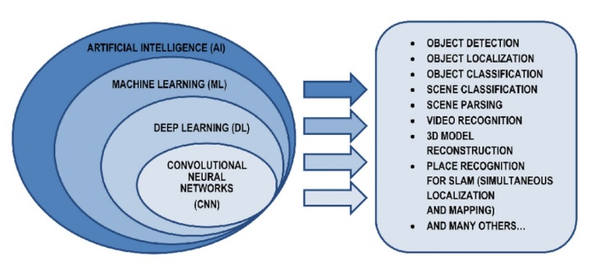

Machine learning
This is a field of artificial intelligence and consists of machines learning from experience. Within this field there are different techniques that are applied to different areas such as the following
- Supervised learning
- Unsupervised learning
- Semi-supervised learning
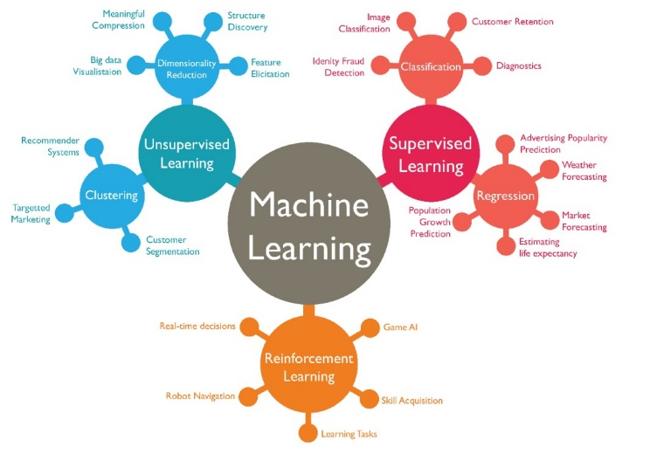

An example of supervised learning is classification which is a form of pattern recognition to predict a class. Classification is divided into two subtypes Binary and Multiclass. Here is an example of multiclass.

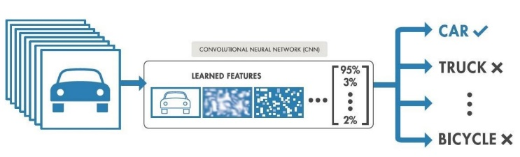

Deep learning
Deep learning is within machine learning and is based on artificial neural networks or ANNs. Let's dive into what neurons are for now.
Also known as Perceptrons, they are mathematical functions that mimic human neurons.

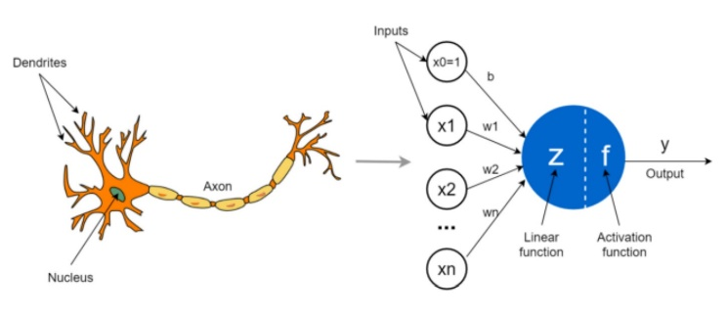

Artificial neurons will have various input signals (such as dendrites), they also have a processing unit in which are the activation and linear functions (such as the nucleus) and an output signal (such as the axon).

Within ANNs there is a special type of neurons which are convolutional neuronal networks (CNNs).

Convolutional neural networks
The main difference between ANNs is that ANNs process each pixel independently, which leads to the loss of textual information along the way. Because of this, ANNs do not distinguish edges, contrasts, geometric figures and other information.

CNN does use contextual information. And it is based on 3 different types of layers: convolutional, pooling and fully connected.

- Convolutional layer: This layer receives as input an image or a feature map, processes it and outputs another feature map. A feature map will be an image reflecting the application of a specific filter. Each filter will be applied independently in each channel. For a black and white image we will only have one channel. And for a colour one we will have 3 which are the RGB.

Filters are matrices whose purpose is to detect shapes, edges, contrast changes and any other type of pattern. These filters can be predefined from a trained network or random values.

- Pooling layer: It is in charge of the dimensionality reduction of the feature maps, and is always used after convolution. Pooling works in a similar way to the convolution operation, a filter is passed over each of the feature maps, the most commonly used being the 2x2 filters. The area that is affected by a filter is called the recpetive field.

There are three types of pooling
Max pooling: retains the most salient feature.

Avarage pooling: preserves the average characteristics of the caps.
Global pooling: Designed for the replacement of the fully connected layer in convolutional networks.

- Flatten layer: converts multi-dimensional lists into one-dimensional lists. It should be noted that this layer increases processing speed.

- Fully connected layer: Similar to ANNs, AND will have as input the output of all convolutional and pooling.

- Dropout layer: This is a way to avoid overtraining. To achieve this it removes some neurons.

Activation functions
Activation functions are a component that allows a neruronal network to become a non-linear model. There are different types of activation.
- Linear function: The formula is as follows
F(x) = x
- Non-linear functions: There are different types of non-linear functions:
Sigmoid: It transforms any input into an output between 0 and 1. Its formula is as follows:
$$f\left(x\right)=\frac{1}{1+ e^{-x}}$$
Softmax: It is a generalisation of the previous one, but focused on a multi-class problem and returns a value between 0 and 1. The function is as follows:
$$f\left(x\right)=\frac{e^{xi}}{\sum_{j=1}^{n}{e^{xj}} }$$
Relu: Used extensively in convolutional neural networks, it acts as a linear function for positive inputs and non-linear for negative inputs.
$$f\left(x\right)=\left\{\begin{aligned}0, &x<0 \\ x, &x≥0\end{aligned}\right.$$

Transfer Learning
It is a technique that improves training with more limited resources. It consists of using a pre-trained model in another task similar to the one you want to perform.

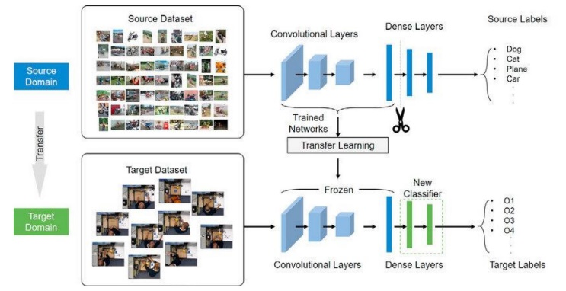

General concepts
In the following, we will explain some cross-cutting concepts for this kind of technology.

- - Training, validation and test set: The training set is data to create and improve the model. The validation set is used to optimise the hyperparameters and to detect overfitting. And finally the test set is used to evaluate the model.

- - Bias and variance: Within classifiers different types of error are known. The irreducible type which means that they cannot be evaluated and the reducible type which can be improved, both bias and variance belong to this type.

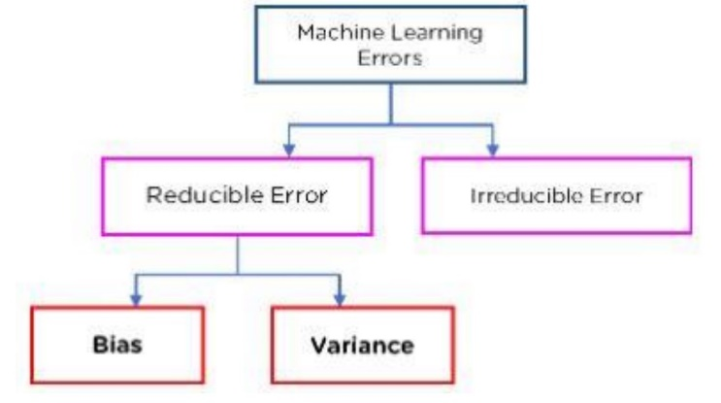

These two types of errors are inversely proportional. Bias in simple terms is the error that exists between the predicted values and the actual values. If this value is very high, it is considered that there is underfitting and that the model is overlooking specific characteristics. Variance measures the variability of the predictions made.

- Hyperparameters: These are the parameters that are set in the creation of a model. Hyperparameters are divided into 2 classes:

Hyperparameters for optimisation, we can name the following Learning rate(adjusts the weights of the network to reduce the error), Bach size(Defines how many data will pass through the model at a time) and number of epochs is called the number of times the data passes through the model.

Hyperparameters for specific models, comprising a specific construction. Such as number of layers and number of hidden units.

- Hyperparameter optimisation: is the search for values to improve the model output. The most important are Random search and Grid search.

- - Data balancing techniques: There is a very common problem when training models, and that is that we encounter an imbalance of the groups of the classes to which an image belongs and for these two solutions have been created:

Oversampling and undersampling, the former consists of multiplying the class for which there is less data to balance the training. Undersampling means reducing the number of data to have a better balance.

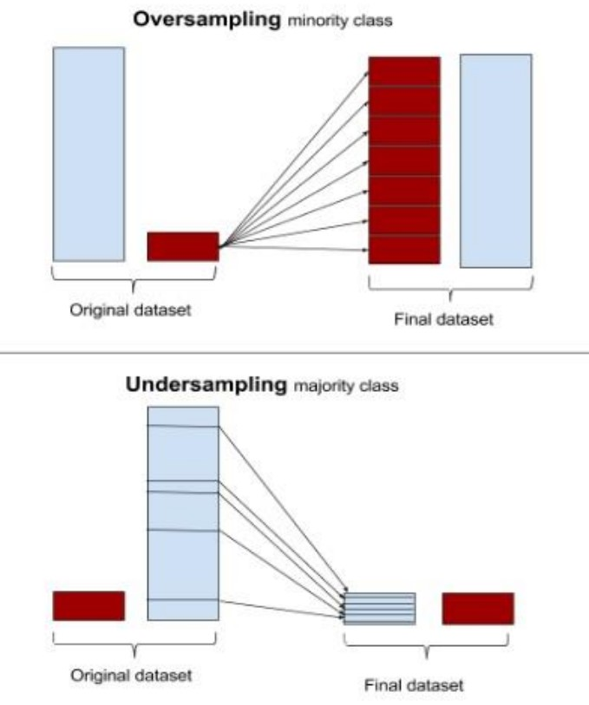

Data Augmentation
This technique is similar to Oversampling but instead of just multiplying the images, it also modifies them in order to have a better trained model..

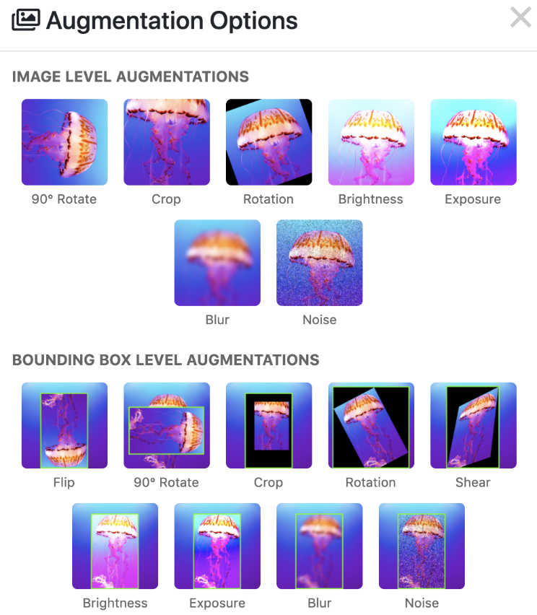

Metrics
To evaluate the results, the accuracy and the loss function are generally used. The accuracy takes values between 0 and 1. On the other hand, the loss function calculates the difference between the predictions and the actual data. There are different methods to calculate this function and, in this case, the cross-categorised entropy method was used. This method works well as it predicts one class with a probability of 1 and the others with 0.

The training also shows the confusion matrix and the classification report shown by scikit-learn.

Hadoop
It is an open-source software platform used to store and process large amounts of data.
To implement this platform, you must create a cluster where we find master nodes and slave nodes, the first has 2 components, namenode which is the one that manages where each part of the data is stored and the Resoucemanager that manages the resources of the cluster. Whenever the Namenode stores the data, it copies it into 3 different parts on the slave node side you have the Datanode which is where the data is stored and the Nodemanager.
To process the Hadoop data, use the MapReduce which is to first divide the tasks into blocks to process them and the second step is to join the processed results.



Apache Spark
It is a technology 100 times faster than hadoop and the difference lies in the fact that it uses the RAM memory of the computers to process the information, as well as being more flexible at the time of implementation as you can configure it with different programming languages such as java, phyton, among others.



L. Medical Applications
The emergence of machine learning and deep learning marked a turning point in medical applications.
Deep Learning now has so many points of research that it is impossible to have a single area of interest.

Within this breakthrough we find that we can read medical studies faster than an experienced professional.

This project does not seek to replace the expert in the area in question but rather to provide a tool where better patient care can be achieved.

METHOD

For this project we will use the data science methodology that works in an effective, efficient and organised way.
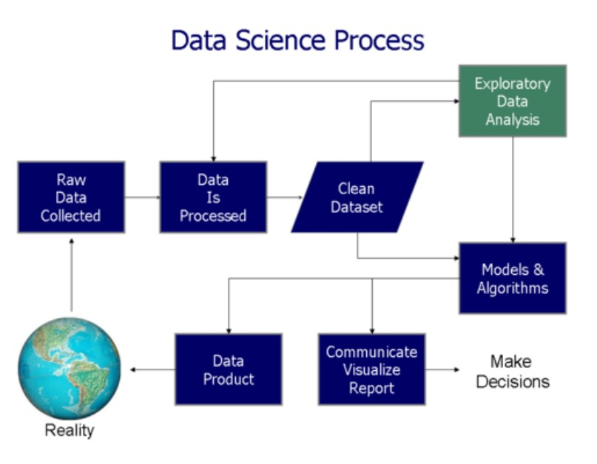

The phases of this methodology are:

- Phase 1: Project definition: We must define what we want to achieve and make a plan with the necessary resources.
- Phase 2: Data collection and preparation: Data will be collected from different sources, such as apis ves, csv databases, etc.
- Phase 3: Data exploration and analysis: Analyse the data, what characteristics should be taken into account.
- Phase 4: Model development: Consists in applying the corresponding algorithms iteratively to improve the model.
- Phase 5: Communication of the results: A consensus must be reached with the relevant parties in order to improve the models.
- Phase 6: Decision-making: Here there are two options: to terminate the project or to consult for a new iteration.

Technologies used
This section will provide information about the technologies used, as well as the programming language, some of the main machine leaning libraries and the development environment.

Programming Languages
Python is a high-level programming language, interpreted and focused on readability. That is why it has been chosen for the development of this project. It is also very popular in data mining and machine learning, some of its features are the following: It is an open source language, it includes object-oriented, imperative and functional programming, it is multi-paradigm and has the possibility to write its modules in other languages (C, C++...).

Hadoop
Apache Hadoop was the original open source framework for distributed processing and analysis of big data on clusters. The Hadoop ecosystem includes related utilities and software such as Apache Hive, Apache HBase, Spark, Kafka, among many others.

Apache Spark
Apache Spark is an open-source distributed processing framework for Big Data. Its main feature is its use of in-memory data structures called RDD, which considerably increases performance compared to tools such as Hadoop.

Tensorflow
Well known in the area of artificial intelligence and phyton. The choice over PyTorch was mainly due to the ease of deployment, especially in the deployment of neural networks.
Within Tensorflow there is the Keras API which is based on Deep Learning and written in phyton.

Scikit-learn
It is an open-source module that provides tools in the field of Machine Learning and was built using the NumPy, SciPy and MatPlotlib modules among others.
It also handles some well-known metrics such as the ROC curve and the AUC score, the classification report and the confusion matrix. We will explain these metrics later.

Matplotlib
It is the free software created to visualise data and graphs and provides an alternative to MATLAB.

Development environment
For the development environment we have chosen to work on an Ubuntu(Linux) virtual machine in Virtualbox to be able to work with the distributed systems technologies Hadoop and Apache Spark. In this Ubuntu operating system we have installed and configured all the necessary libraries such as Tensorflow among others.

Jupyter is a web IDE that allows you to run Python code.
Virtual Machine is a system that simulates the software of an operating system.

Data
In the data collection, the data has been extracted from the Kaggle website.
The data used are freely available under a Creative Commons Attribution-Non Commercial 4.0 International License (CC-BYNC).

Dataset
The dataset was created in August 2023, and is structured as follows, we have three folders train, valid and test. Train has 85% of images, Valid has 10% of images and Test has 5%. Each folder has a cvs consisting of the following columns:
- Filename
- width
- height
- class
- xmin
- ymin
- xmax
- yma

Technical limitations
In the course of the project, several problems were encountered, for example: the installation of libraries that required more optimal hardware capabilities and that were not found in a virtual machine. Also, these virtual machines do not have the CUDA libraries that considerably accelerate data processing.

V. IMPLEMENTATION AND DEVELOPMENT
This section will explain the implementation to achieve the classification of dental X-ray images. The steps for this include the preparation of models with their respective hyperparameters and the tests to find the optimal ones.

Preparation of the models

Hyperparameter setting

Results

Redes preentrenadas

References
The template will number citations consecutively within brackets [1]. The sentence punctuation follows the bracket [2]. Refer simply to the reference number, as in [3]—do not use “Ref. [3]” or “reference [3]” except at the beginning of a sentence: “Reference [3] was the first ...”
Number footnotes separately in superscripts. Place the actual footnote at the bottom of the column in which it was cited. Do not put footnotes in the abstract or reference list. Use letters for table footnotes.
Unless there are six authors or more give all authors’ names; do not use “et al.”. Papers that have not been published, even if they have been submitted for publication, should be cited as “unpublished” [4]. Papers that have been accepted for publication should be cited as “in press” [5]. Capitalize only the first word in a paper title, except for proper nouns and element symbols.
For papers published in translation journals, please give the English citation first, followed by the original foreign-language citation [6].

- G. Eason, B. Noble, and I. N. Sneddon, “On certain integrals of Lipschitz-Hankel type involving products of Bessel functions,” Phil. Trans. Roy. Soc. London, vol. A247, pp. 529–551, April 1955. (references)
- J. Clerk Maxwell, A Treatise on Electricity and Magnetism, 3rd ed., vol. 2. Oxford: Clarendon, 1892, pp.68–73.
- I. S. Jacobs and C. P. Bean, “Fine particles, thin films and exchange anisotropy,” in Magnetism, vol. III, G. T. Rado and H. Suhl, Eds. New York: Academic, 1963, pp. 271–350.
- K. Elissa, “Title of paper if known,” unpublished.
- R. Nicole, “Title of paper with only first word capitalized,” J. Name Stand. Abbrev., in press.
- Y. Yorozu, M. Hirano, K. Oka, and Y. Tagawa, “Electron spectroscopy studies on magneto-optical media and plastic substrate interface,” IEEE Transl. J. Magn. Japan, vol. 2, pp. 740–741, August 1987 [Digests 9th Annual Conf. Magnetics Japan, p. 301, 1982].
- M. Young, The Technical Writer’s Handbook. Mill Valley, CA: University Science, 1989.

IEEE conference templates contain guidance text for composing and formatting conference papers. Please ensure that all template text is removed from your conference paper prior to submission to the conference. Failure to remove template text from your paper may result in your paper not being published.

